KYLE RAYNER
ksrayner@deakin.edu.au
Abstract
This Game Design Document details my Cycling Against Friends/Ghosts feature that I’ve been working during the Capstone Program. This document expands upon the ideas covered in the Feature Proposal Document and also includes the design work that has taken place thus far.
Game DesiGn Document
SIT378 – Team Project (B) – Execution and Delivery

Contents
Vision, Scope & Goals 2
Must Have Features: 2
Would Like Feature: 2
Summary of Contributors 2
Key Requirements Summary 3
Design 3
Technology 3
People 4
Timeframe 4
Concept Summary 6
Title 6
Gameplay Hook 6
Genre 6
Platform 6
Target Audience 7
Gameplay 7
Realistic Cycling 8
Casual Cycling 9
Track Building 10
Art Design 10
User Interface Design 11
In-Game UI Design 11
Out of Game Ui Design 12
Controller/Controls Design 15
Level Design 15
Technical Design 15
Requirements Analysis 15
References 16
Appendix 16

Vision, Scope & Goals
This document will detail my Cycling Against Friends/Ghosts feature designed for the Smart Bike project within the Redback Operations organization. This feature consists of three main game modes/components which include Realistic Cycling, Casual Cycling and Tracking Building. Realistic Cycling is a realistic, competitive game mode for serious cyclists and fitness enthusiasts. Casual Cycling is a more casual game mode with playful mechanics and elements. Track Building is a track building system where players can create, share and play their own tracks and also other people’s tracks.
The vision for this project is to create a fun and immersive experience for seasoned cyclists, fitness enthusiasts and casual cyclists/gamers alike. This will be achieved with the three aforementioned game modes that will enable different ways of interacting with the Smart Bike. One of the main objectives of this feature is to provide a fun and engaging experience where people can compete with each other in various ways while engaging in physical activity with the Smart Bike.
Provided below are the main goals of this feature:
- Increase the gamification of the Smart Bike project by adding more interactive and engaging elements
- Provide a multiplayer experience that adds competitive and challenging aspects
- Provide users a way of creating, sharing and playing tracks that they and others make
Due to time constraints, the main focus for this trimester is the realistic and competitive game mode for serious cyclists and fitness enthusiasts. The goals for this component of the feature are listed below:

Must Have Features:
- The player must be able to compete against another person
- The player must be able to compete against their own personal best time (Ghost)
- The player must have at least one track/course/circuit/distance/other to compete on
- The player must be able to see statistics on both their own performance, the performance of their competition (speed, distance completed, etc) and clearly indicate who is winning both during and after the race
- For the mobile version, in accordance with the Figma designs, the player must have access to the first two interfaces as shown in Figure 12 and Figure 13.

Would Like Feature:
- For the mobile version, in accordance with the Figma designs, the player has access to the final interface as shown in Figure 12 and Figure 13.
- For the mobile version, the player will be able to select coordinates from a map and use that as the course/track when competing against a friend or ghost
- The player can choose from more than one track/course/circuit/distance to compete on
- The player can compete against other people’s ghosts (e.g., friend’s ghost or a preloaded ghost from another person’s performance)

Summary of Contributors
Several teams within the Redback Operations company will be contributing to the development of this feature. The teams involved include the IoT and Embedded Systems team, the Virtual Reality Development team and the Mobile Application team. It is possible that people from other teams may also contribute to this project at some point in the future.

Key Requirements Summary

Design
The design of this feature started in the first part of the Capstone Program in trimester 2 of 2022. This consisted mostly of pitching the idea, fleshing out the concept and designing the look and feel of it based on the current work done within Redback Operations. For example, the designs for this feature had to fit in with the designs that the Mobile Application team had already created. Going forward, Redback Operations will be focusing on developing a prototype for the Realistic Cycling component of this feature. Specifically, our efforts will be implementing this feature in a Virtual Reality application that the Virtual Reality Development team has been working on. The IoT and Embedded Systems team and Virtual Reality Development team will be working together on this.

Technology
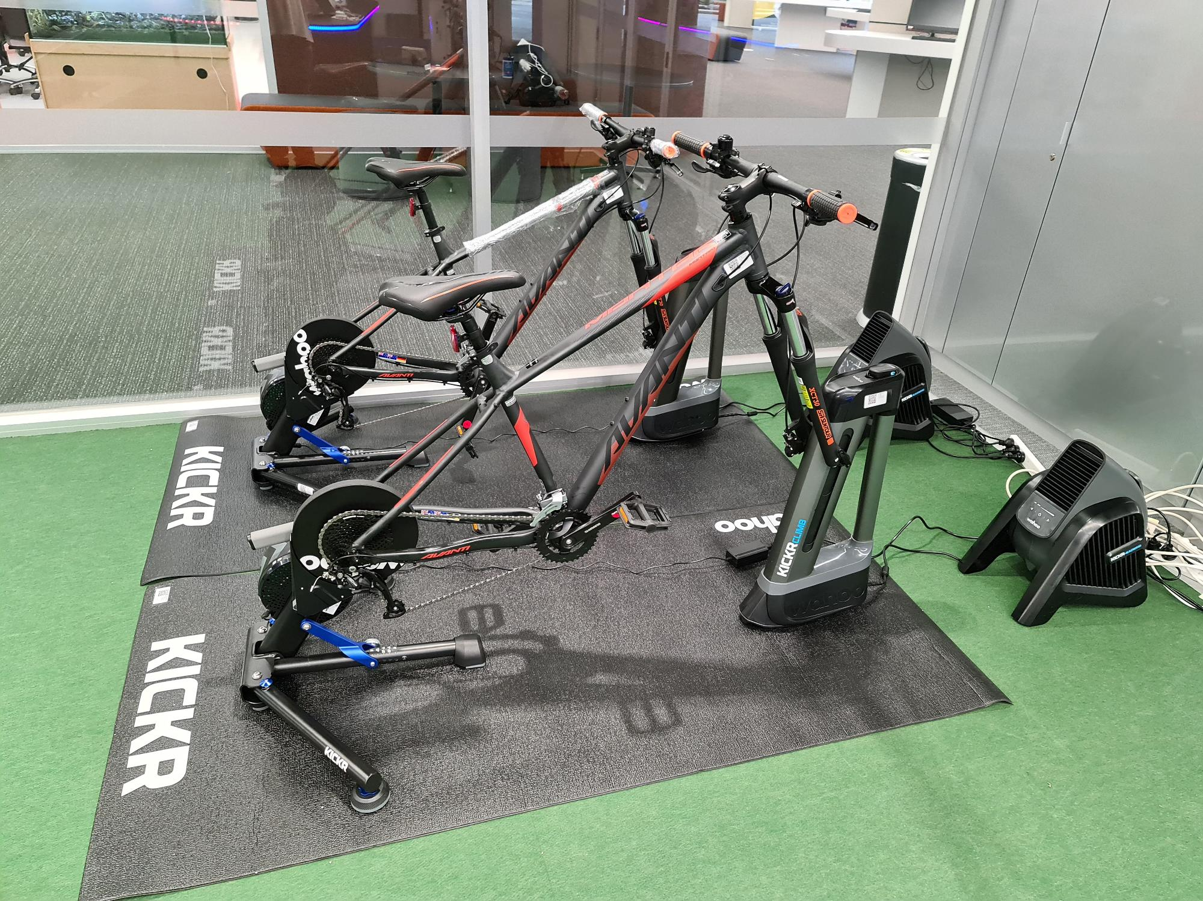
Figure 1 – Two Smart Bikes that have been constructed by Redback Operations
The Smart Bike project is a relatively complex project with many technologies already going into them. The Smart Bikes as shown above already uses many different technologies such as Bluetooth, ANT+, MongoDB database, MQ Telemetry Transport (MQTT) and a number of different sensors and hardware. On top of that, we are using several other technologies to develop end user interfaces such as Virtual Reality applications, a mobile application and a web app for the browser. The Virtual Reality applications will be created using the Unity Game Engine and the mobile application will be made using Flutter.
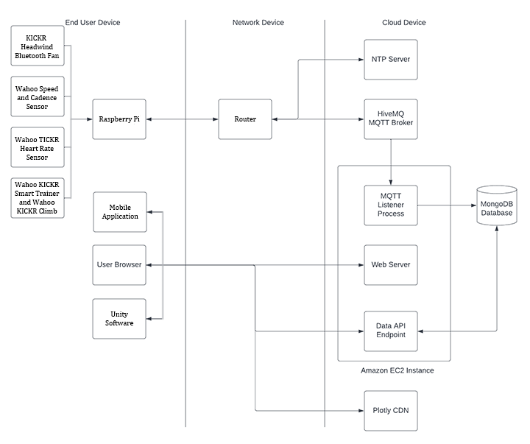
Figure 2 – Suitable Architecture based on the architecture provided by Adrian Grigo and modified by myself

People
People within the Redback Operations company of the Capstone Program will be involved in the development of this feature. As mentioned above, this will include the IoT and Embedded Systems team, the Virtual Reality Development team and the Mobile Application team. However, it is possible that people from other teams within the Redback Operations company may contribute to developing this feature.

Timeframe
This feature is quite significant in terms of complexity and time required to make it a reality. Therefore, this feature has been split into three distinct components as outlined in the Vision, Scope and Goals section above. For this trimester, Redback Operations will focus their efforts on the Realistic Cycling game mode and by the end of the 6-week trimester hopefully have a working prototype of it. Below is a roadmap of making this aspect of the feature a reality by the end of trimester which has been taken directly from the ‘Roadmap for Cycling Against Friends/Ghosts Feature’ document. It uses the ‘Must Have’ and ‘Would Like’ features list from the Vision, Scope and Goals section to identify what is necessary and a plan of action to get those items done. Each development cycle is ideally meant to be one week.

Development Cycle 1: | - The player must be able to compete against their own personal best time (Ghost)  - Focusing on the core aspect of the feature by adding the ability to compete against your ghost in its most basic form.  - The player must have at least one track/course/circuit/ distance/other to compete on  - For the mobile version, a distance such as 10km or 20km would suffice. A countdown timer like what is shown in Figure 12 and Figure 13 would also be a viable option.  - For the video game version, a track, circuit or course would be more appropriate to add to the immersive experience.
Development Cycle 2: | - The player must be able to compete against another person  - This adds to the work done in Development Cycle 1.  - Mostly involves setting up another bike and being able to compete against the person on it.  - Finishing Figma designs for both starting a workout and ending a workout for this feature  - Most of the design work is done. However, to prepare for the next development cycle, all the Figma designs should be complete.
Development Cycle 3: | - The player must be able to see statistics on both their own performance, the performance of their competition (speed, distance completed, etc) and clearly indicate who is winning both during and after the race  - For the video game version, most of this information will be located in one of the corners via a heads-up display (HUD). To indicate who is winning, text in the top-middle of the screen will appear periodically as shown in Figure 3.  - For the mobile version, in accordance with the Figma designs, the player must have access to the first two interfaces as shown in Figure 12 and Figure 13.  - These two interfaces provide vital information regarding their own performance and the performance of their competition
Development Cycle 4: | - Finishing off any work from previous development cycles  - Chance to catch up on any work from previous weeks  - Quality assurance and testing  - Wrap up any development and ensure the feature is in a working state  - Work on ‘Would Like’ features if time permits  - Some of the ‘Would Like’ features from the list above may be implemented at this point.

Further work can be carried out in future trimesters with a focus on improving and polishing the Realistic Cycling game mode and also implementation of the Casual Cycling game mode and the track building game mode.

Concept Summary

Title
The official title of the feature is ‘Cycling Against Friends/Ghosts’. The three game modes/components of the feature have been referred to as ‘Realistic Cycling’, ‘Casual Cycling’ and ‘Track Building’.

Gameplay Hook
As a result of this feature being included in the overarching Smart Bike project, this section will be focused on the Smart Bike project itself instead of this feature. The Smart Bike itself is a programmable indoor exercise bike with overlaying software including a Virtual Reality application, a mobile application and web interface. The idea is to provide an engaging and interactive experience to help make exercising more enjoyable. This feature fits into both the Virtual Reality application and the mobile application. Ideally, this feature will help increase the gamification of the Smart Bike project by adding more engaging and interesting elements to an already great project.

Genre
The Smart Bike project as a whole is an exercise bike with accompanying software that will gamify exercising. This feature will be built into a Virtual Reality game and therefore would be considered a sports game.

Platform
The Cycling Against Friends/Ghosts feature will be available on both mobile devices and also devices capable of Virtual Reality. This could include VR headsets, traditional consoles (PS5, Xbox Series X and Series S) and PC’s.

Target Audience
Through much consideration, a primary and secondary target audience has been identified and detailed in the table below:
 | Primary Audience | Secondary Audience
Age | 15-45 | 10-60
Gender | 50/50 | 50/50
Type of Person | Serious Cyclist/Fitness Enthusiast | Casual Gamer/Cyclist
Likes | - Enjoys a challenge  - Wants competition  - Realistic experience  - Be rewarded for great efforts | - Likes a social experience  - Variety of tracks  - Fun and engaging game mechanics
Dislikes | - Complicated starting up process (e.g., technology)  - Unfair mechanics (e.g., rubber-banding) | - Too competitive  - Difficult to get started (complicated mechanics)
Preferred Platform | - Doesn’t matter as long as it’s easy to get up and running | - PC  - Virtual Reality Headset  - Mobile Phone

Based on the information in the table, we have two distinct target audiences. The Cycling Against Friends/Ghosts feature will cater to the identified audiences through the two distinguishable game modes known as Realistic Cycling and Casual Cycling. The idea behind this is that these two different game modes together offer exactly what our target audiences want from such an experience. The Track Building system coincides with the above two game modes by allowing and encouraging users to share their own tracks and also race on other people’s tracks.

Gameplay
The Smart Bike project is designed to mimic real world conditions such as changing the resistance of the wheels, changing the incline of the bike and also factoring in windspeed. The idea is that the Smart Bike can offer a very realistic and true to real life cycling experience. This feature uses that base to add fun and engaging elements on top of that to help gamify the experience. As mentioned in the Vision, Scope and Goals section above, this feature contains three game modes. Each of these game modes will be explained in detail below.

Realistic Cycling
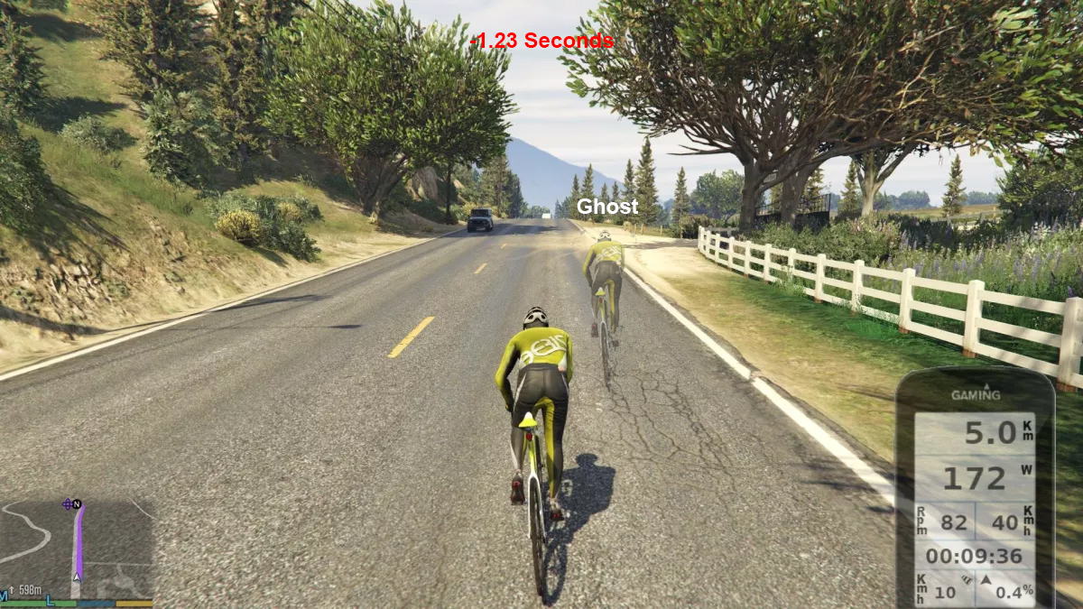
Figure 3 – Concept Art for the Realistic Cycling game mode
This game mode is where the feature began. The main idea behind this game mode is to give users a realistic cycling experience on the smart bike while adding competitive elements to it. The competitive elements are specifically being able to compete against friends and also ghosts (as seen in Figure 3). The user will be able to select different tracks/circuits/distances and choose the competition. Races could potentially be rather time consuming in order to provide an experience that is intense and suited to improving the person’s cycling ability and/or fitness levels. Realistic Cycling will be available on both mobile and also Virtual Reality systems. Below is a list of mechanics and gameplay elements for this game mode.
- The user can compete against friends. To begin with, this will be through setting up another smart bike and enabling multiplayer on the VR game and mobile application. Eventually, this could take the form of a friends list.
- The user can compete against ghosts. Fundamentally, this will be the personal best time of the person using the smart bike for a specific track, course, distance, etc. However, this could be extended to include friend’s ghosts and also compete against ghosts from a leader board.
- The user can select various workout options including different tracks, distances, time and even choosing coordinates (mobile only). This list could expand quite substantially to include different and more personalized training options such as interval training.
- The user can see statistics on both their own performance, the performance of their competition (speed, distance completed, etc) and clearly indicate who is winning both during and after the race.
- The user will have a reasonably realistic cycling experience with the intention of it being as close to real life as possible.

Casual Cycling
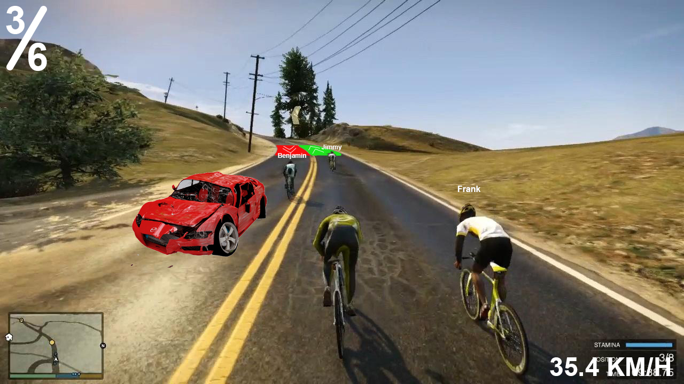
Figure 4 – Concept Art for the Casual Cycling game mode
This game mode provides a more casual experience for users. This includes a number of changes to the Realistic Cycling game mode. Races will be much shorter with an expected timeframe of around 5 to 10 minutes depending on the track. Furthermore, this game mode will have rubber banding which will enable anyone to win regardless of cycling skill. This will be done in the form of power-ups, boosts, objects that need to be dodged, etc. This game mode will only be available on Virtual Reality systems. Below is a list of the key features of this game mode.
- The user can select between different tracks and courses and can also choose the number of laps if applicable.
- Generally speaking, races will take around 5 to 10 minutes to finish.
- The user will be competing against other people and artificial intelligence to have a sizable roster of around 6 to 8 competitors.
- All tracks and courses will contain obstacles that the user will need to dodge to maintain speed. If the user fails to dodge an obstacle, the user will lose a significant amount of speed or respawn just after the obstacle. Obstacles can include broken down cars, piles of junk, jumps that need to be cleared and also poles & walls.
- All tracks and courses will include boost pads and slow-down pads. A combination of both can also be used. Boost pads will increase the speed of the bike if the user rides over them and slow-down pads will decrease the speed of the bike. Both kinds of pads can be used in conjunction with each other as shown in Figure 4. The user would have to try hit the boost pad in order to increase the speed of the bike instead of losing speed.
- Power-ups will be available to players. This could potentially be a time-based system such as getting a power-up every 30 seconds or a collectible that can be found on the track or course. Power-ups may include speed boosts for yourself, projectiles to slow down other competitors and even being able to place down obstacles and slow-down pads to inconvenience other competitors.
- Tracks and courses may contain shortcuts which will be more difficult to pull off than following the track. However, shortcuts will save a decent amount of time.
- The user will have a Heads-up Display (HUD) that will provide useful information such as their position in the race, laps to go and some other useful information.
- An end race interface will be shown to the user after the race. This interface will provide a number of statistics regarding the race such as all the competitor’s positions and some records such as highest speed achieved.

Track Building
This game mode will enable users to create tracks/circuits themselves. Tracks could be created for both the Realistic Cycling and Casual Cycling game modes. The game mode will allow players to create tracks off a tile placing system similar to the track building system that is part of TrackMania 2020. A system like that would be suitable for this game mode as it would be relatively straightforward and simple to use. Track Building will be a Virtual Reality exclusive game mode. Below are some of the features that this game mode offers.
- Users will be able to create tracks and courses for both the Realistic Cycling and Casual Cycling game modes. Users will have to select which game mode they want to make a track or course for as soon as they load up this game mode.
- Tracks and courses will be made using a grid and tile system. The user will be able to select tiles and place them on a grid. Tiles will fundamentally include everything that the user would need to create a track as well as tiles specifically for aesthetics. Examples of tiles includes corner tracks, straight tracks, tree tiles, obstacles tiles, etc. Different terrain tiles will also be available such as grass, dirt, concrete, etc.
- Users will be able to save, share and play their own tracks/courses and also other people’s tracks/courses.
TrackMania 2020 Track Editor Video: https://www.youtube.com/watch?v=ppcYELjeEDE

Art Design
For the art design, it will closely resemble the VR game that is in development as this feature will be incorporated into that project. Below is a screenshot from the current build of Project Sun Cycle. This is, in essence, what the art design of this feature will roughly look like.
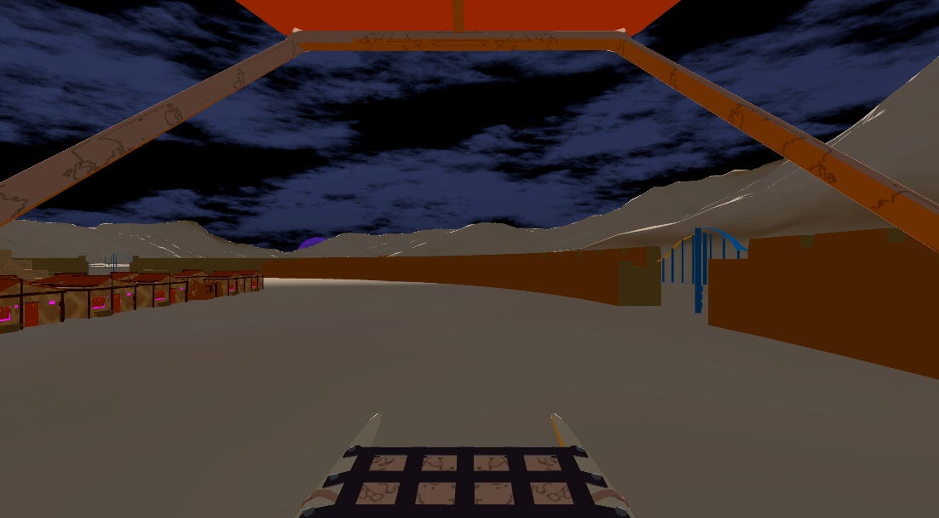
Figure 5 – Screenshot from the current build of Project Sun Cycle

User Interface Design

In-Game UI Design
This feature will be available in both Virtual Reality and mobile and will therefore have vastly different interfaces to suit their respective applications and platform. Details of this are provided below.
The design of the Virtual Reality version of this feature is shown in Figure 6. It showcases the current art style of the VR game as well as the final design of the Heads-Up Display (HUD). As shown in the figure below, several useful statistics will be displayed to the user which includes speed, cadence, heartrate, calories, current workout duration and also position. Along the bottom is a progress bar showing the user’s current progress on the course or progress on a lap of a track. The only aspect missing is that periodically a number showcasing how the user is doing compared to their friend/ghost will appear near the top of the interface like what is shown in Figure 3. This will either be triggered by a checkpoint or just after a certain amount of time has passed.
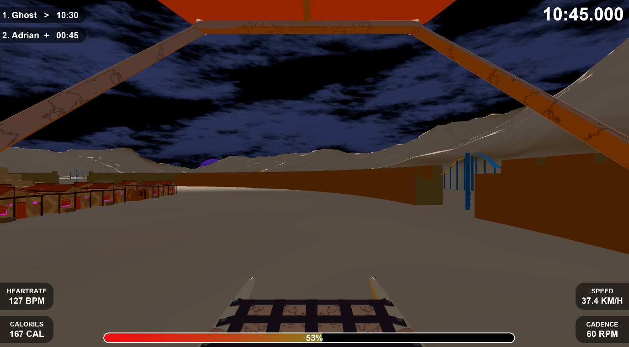
Figure 6 – Final Design for the HUD of the VR game developed in Photoshop
The mobile version of this feature will be built into the mobile application that Redback Operations has been developing. The mobile app is more fitness focussed and therefore this feature has been altered to fit into the mobile application while still providing some interesting and engaging elements. Below are the three interfaces shown during a workout. The first interface is very similar to what the mobile application team had developed. This interface is focussed on the performance of the user and showcases a number of statistics such as speed, cadence, heart rate, etc. The next two interfaces are geared towards showcasing how the user is doing compared to their competition whether that is another person or a ghost (personal best). The second interface is quite similar to the first interface in that it is very focussed on the performance of the user and the competition and showcases the most important statistics of both parties. The third and final interface is designed to be a visual approach to showcasing important information while still providing some statistics that are useful such as showing that the user is -300m behind the ghost. The user can change between any of the interfaces at any time during a workout so they can choose the interface that they feel is most useful at the time.
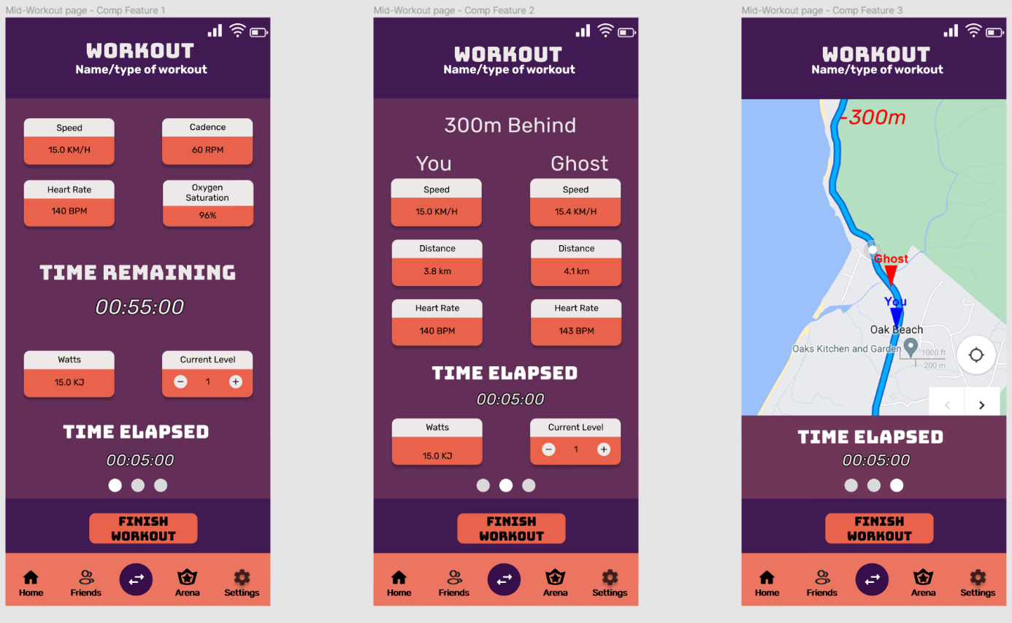
Figure 7 – The three interfaces that are shown mid-workout for the Cycling Against Friends/Ghosts Feature

Out of Game Ui Design
As with the in-game user interface, the out of game user interface is quite different between the two versions of this feature. Details of the differences will be provided below.
As this feature is being built into the Virtual Reality application that the VR team has been working on, it will fit into their designs. Figure 8 showcases what the main menu from the Virtual Reality application looks like.
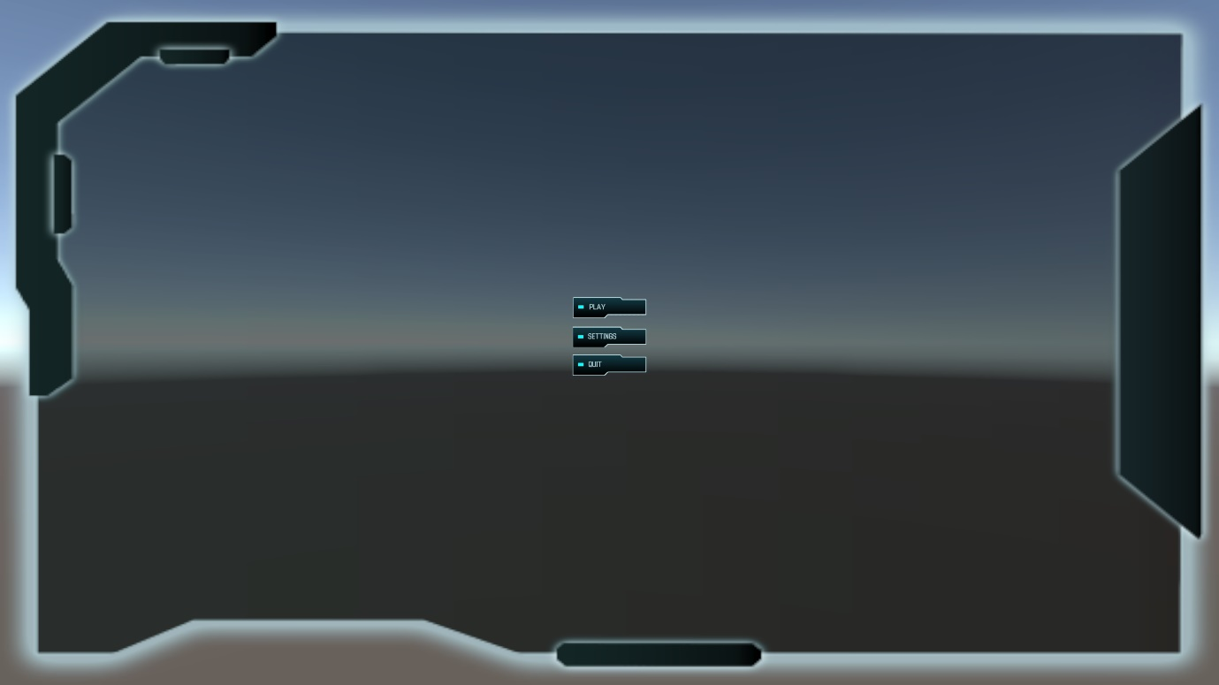
Figure 8 – Design of the Main Menu of the Virtual Reality application that the VR team has been working on
For this feature, I made a multiplayer menu which takes into account what the VR team had already done and extended upon it. The below two screenshots showcase the designs for the multiplayer menu.
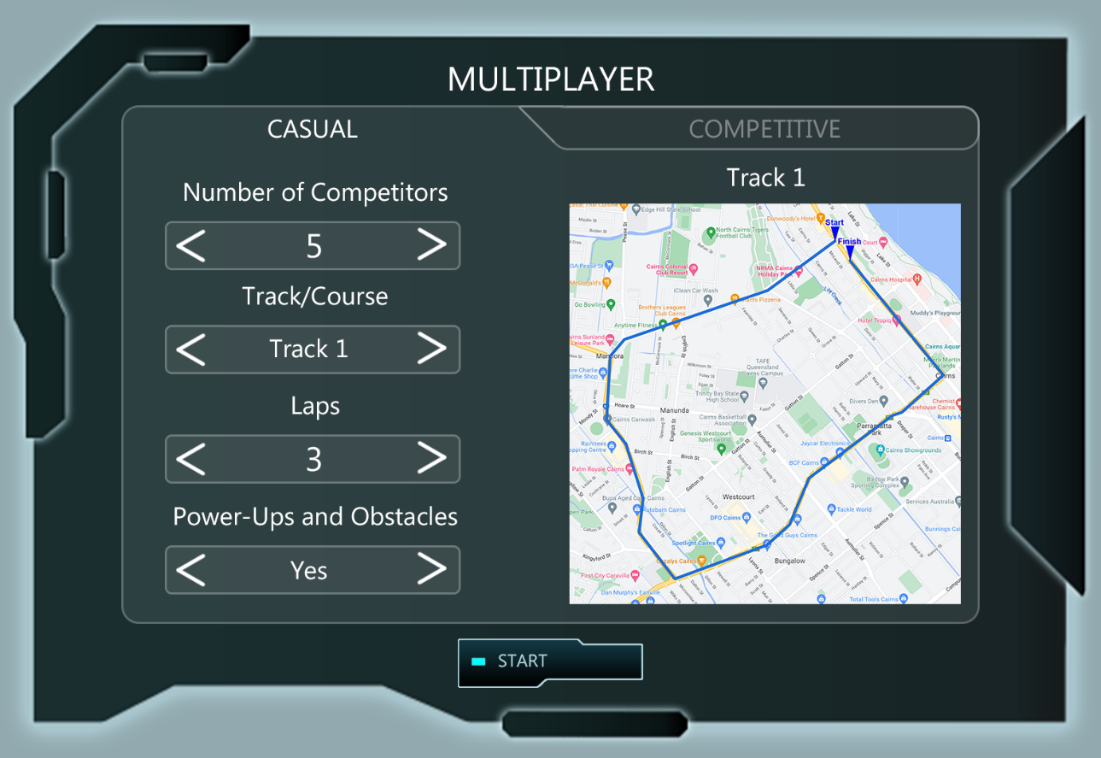
Figure 9 – The design for the options of the casual game mode of the multiplayer menu
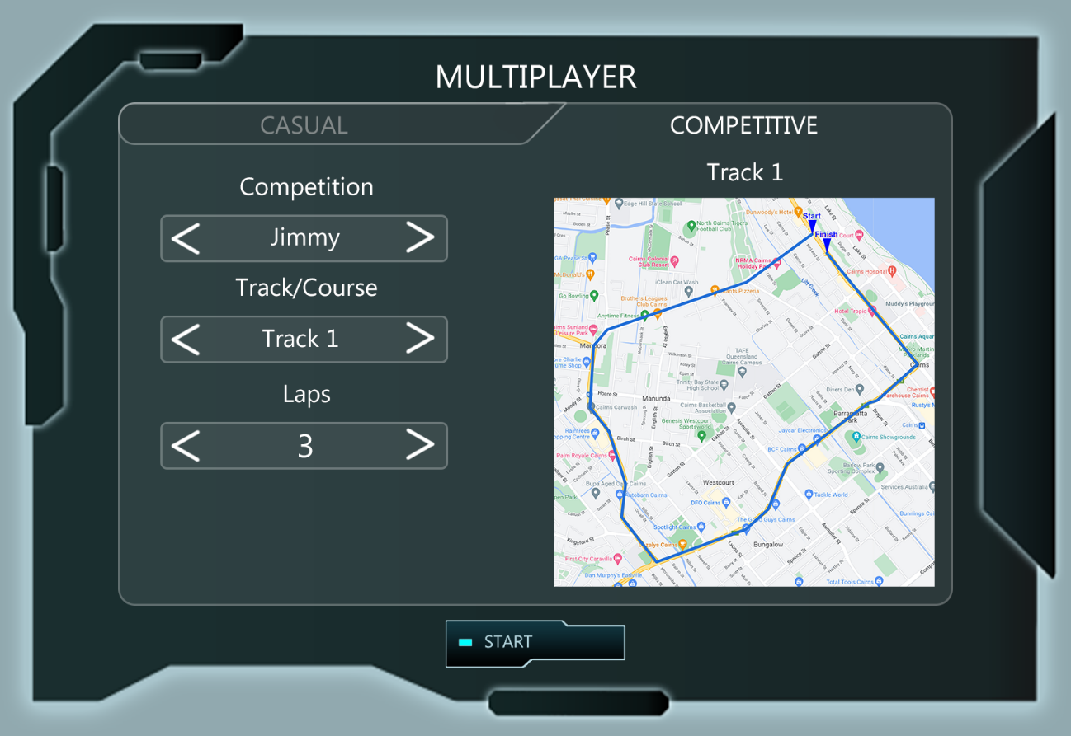
Figure 10 - The design for the options of the competitive game mode of the multiplayer menu
The out of game interface for the mobile application will have similarities to some of the fitness apps on the market as it is fundamentally a fitness app itself. Therefore, the app will include interfaces to start a workout and to finish a workout among many more. Below are the interfaces that are most relevant to this feature.
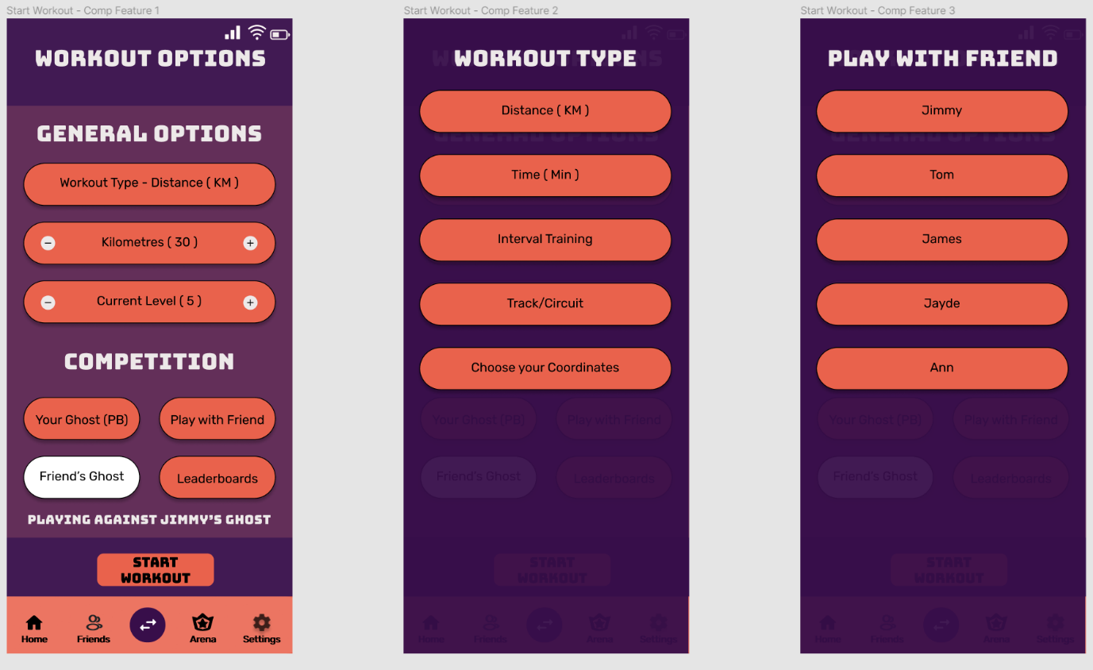
Figure 11 – Some of the interfaces that are shown before stating a workout for the Cycling Against Friends/Ghosts Feature
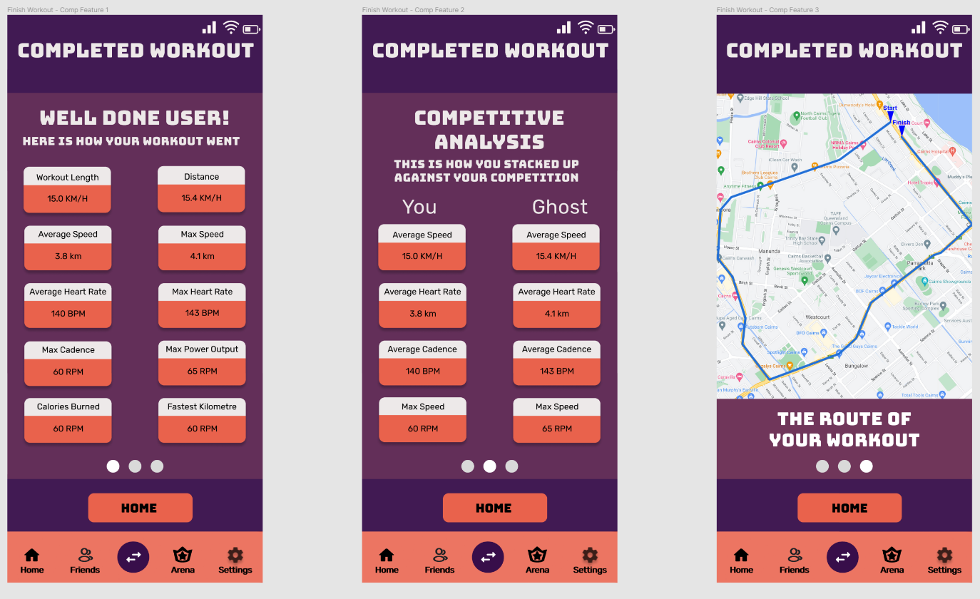
Figure 12 – The three interfaces that are shown after a workout for the Cycling Against Friends/Ghosts Feature
For a more comprehensive view of all the Figma Designs: https://www.figma.com/file/tvpePId4wuKneyD9faU1yw/Mobile-App-Flow?node-id=0%3A1

Controller/Controls Design
For the Smart Bike project as a whole, Redback Operations is focusing on simple and effective control design. The user will ultimately be riding a bike so controls that are intuitive and easy-to-use will be the most appropriate for the Smart Bike project and also this feature. The smart bike itself is the primary way of interacting with the system as a whole. By pedalling the pedals, the user is propelled forward in the VR game and in the mobile application. Multiple methods of steering the smart bike are in the works. This includes adding a sensor to the handlebars to detect orientation, a method that enables squeezing the handlebars to trigger turning and also using VR controllers to enable steering of the smart bike. As for the menus, the VR game will make use of VR controllers and the mobile application will be interactable through touch.

Level Design
The Smart Bike project and its accompanying Virtual Reality game and mobile application are primarily focused on exercise and gamifying the experience. Therefore, users will be able to select tracks/circuits/distance, etc from a list depending on what they want to do. The Virtual Reality version of this feature will have pre-built tracks and courses as well as user-built tracks and courses. Whereas the mobile version of this feature will be a bit more limited in this regard. The mobile version will allow users to select a distance to ride, an amount of time to ride, a simplified version of a track or circuit and also be able to choose your own coordinates.

Technical Design

Requirements Analysis
This feature will be available within the VR game and mobile application of the Smart Bike project. Therefore, the platforms that this feature could potentially become available on include VR headsets (e.g., Meta Quest 2), traditional consoles (PS5, Xbox Series X and Series S), PC, Android and IOS.
The Smart Bike project already uses a number of technologies to bring it to life. This feature, however, will primarily be created using the following technologies. The Unity Game Engine will be used to create the VR game and Flutter will be used to create the mobile application. Any artwork needed will by made in Adobe Photoshop or GIMP and the 3D modelling software of choice will be Blender. Several other technologies may be used alongside the aforementioned technologies as well.
Some system intelligence will be programmed for this feature. For the Casual Cycling game mode, artificial intelligence (AI) will be required. Races are intended to have around six to eight competitors and AI cyclists may make up a good chuck of this amount.

References
Bains C (2022) You can now pedal around GTA 5 using real-life smart bike, TechRadar, accessed 9 November 2022. https://www.techradar.com/news/you-can-now-pedal-around-gta-5-using-a-real-life-smart-bike
GTA Base (n.d.) Triathlons, GTA Base, accessed 25 November 2022. https://www.gtabase.com/grand-theft-auto-v/side-missions/triathlons
PNG Find (n.d.) Damaged Car, PNG Find, accessed 25 November 2022. https://www.pngfind.com/mpng/ioRmmwR_damaged-car-mazda-rx-8-hd-png-download/
RHG (2017) Top-down view of a track, RHG, accessed 3 December 2022. https://www.rye-house.co.uk/on-track-advertising/
Rockstar North (2013) Grand Theft Auto V, Computer Program, Edinburgh, Scotland

Appendix
I have compiled all the design work for this feature that has taken place over the course of trimester 2 and trimester 3.
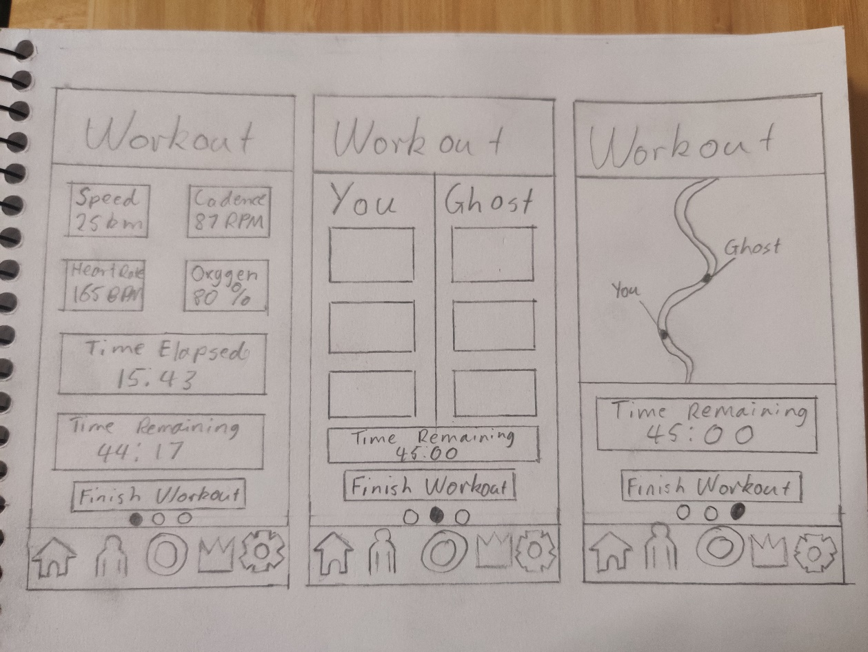
Figure 13 – Initial mock-ups of the mid-workout interfaces
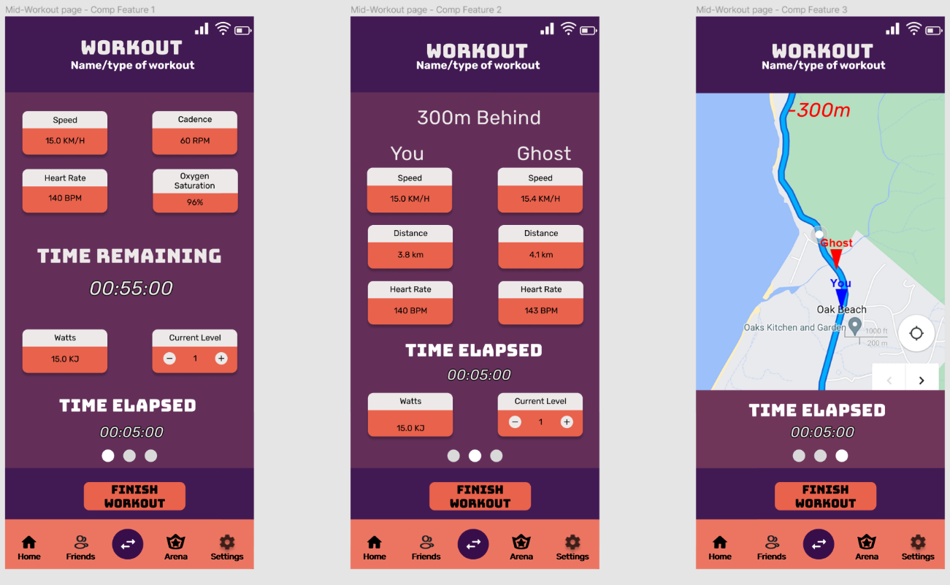
Figure 14 – Final designs of the mid-workout interfaces (alternative 1)
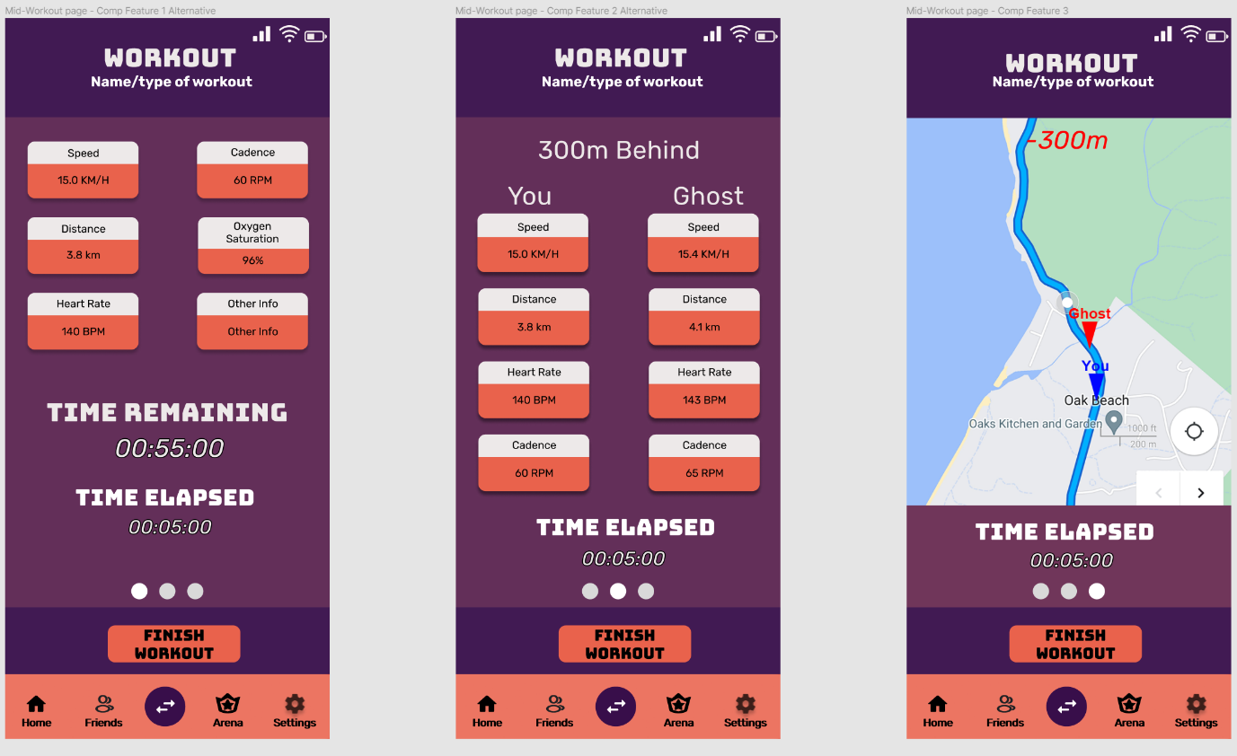
Figure 15 – Final designs of the mid-workout interfaces (alternative 2)
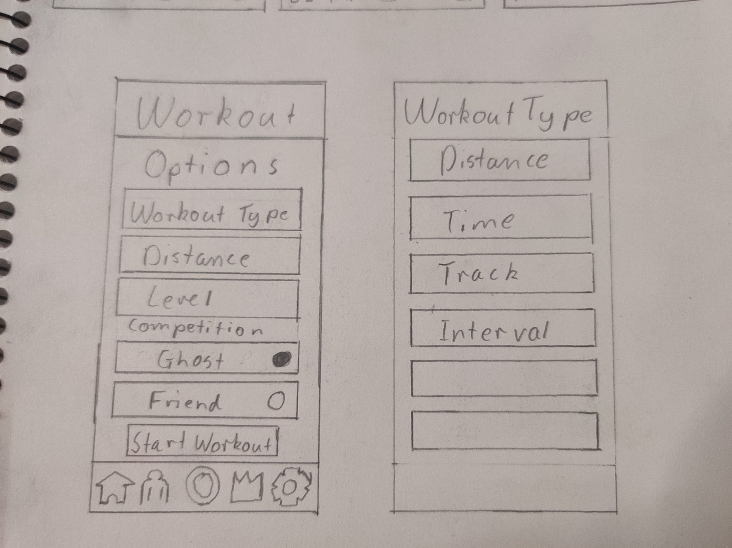
Figure 16 – Initial mock-ups of the workout options interfaces

Figure 17 – Final designs of the workout options interfaces
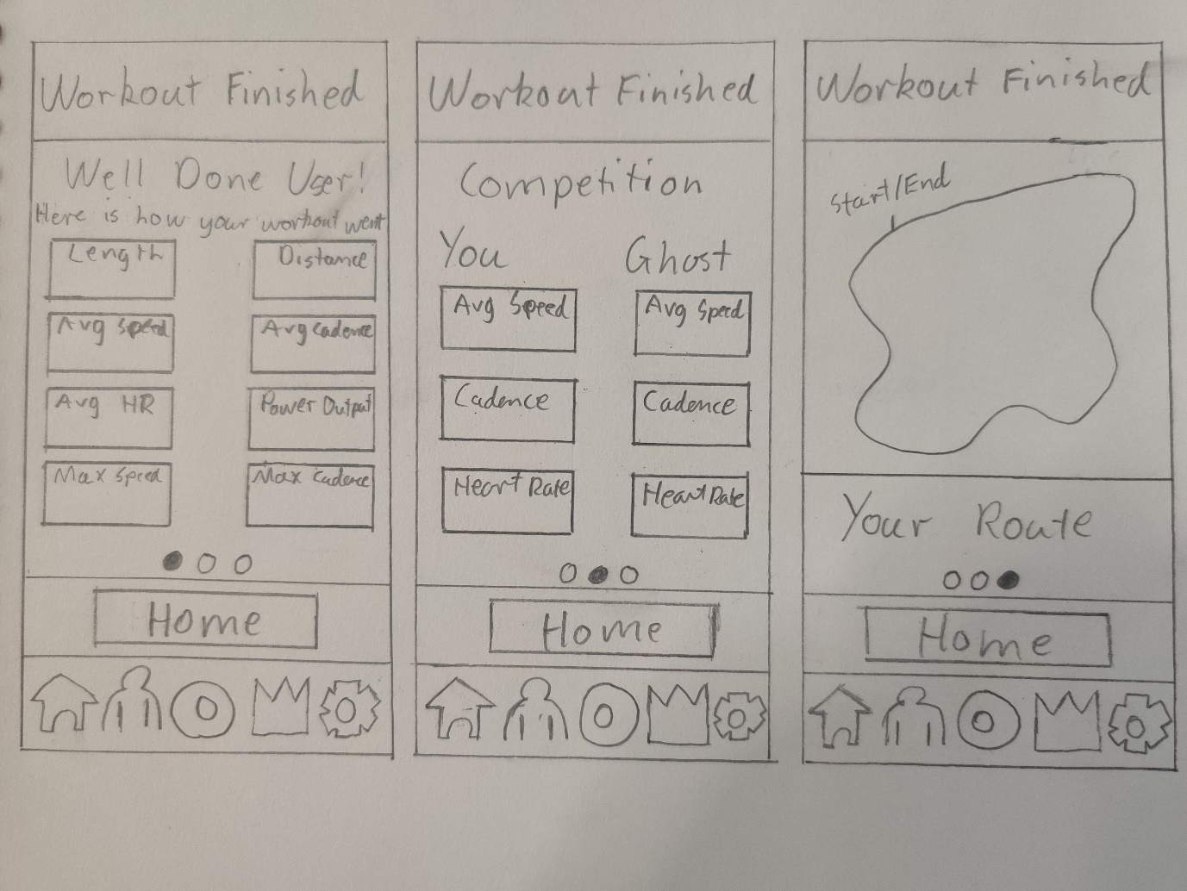
Figure 18 – Initial mock-ups of the finished workout interfaces
Figure 19 – Final designs of the finished workout interfaces
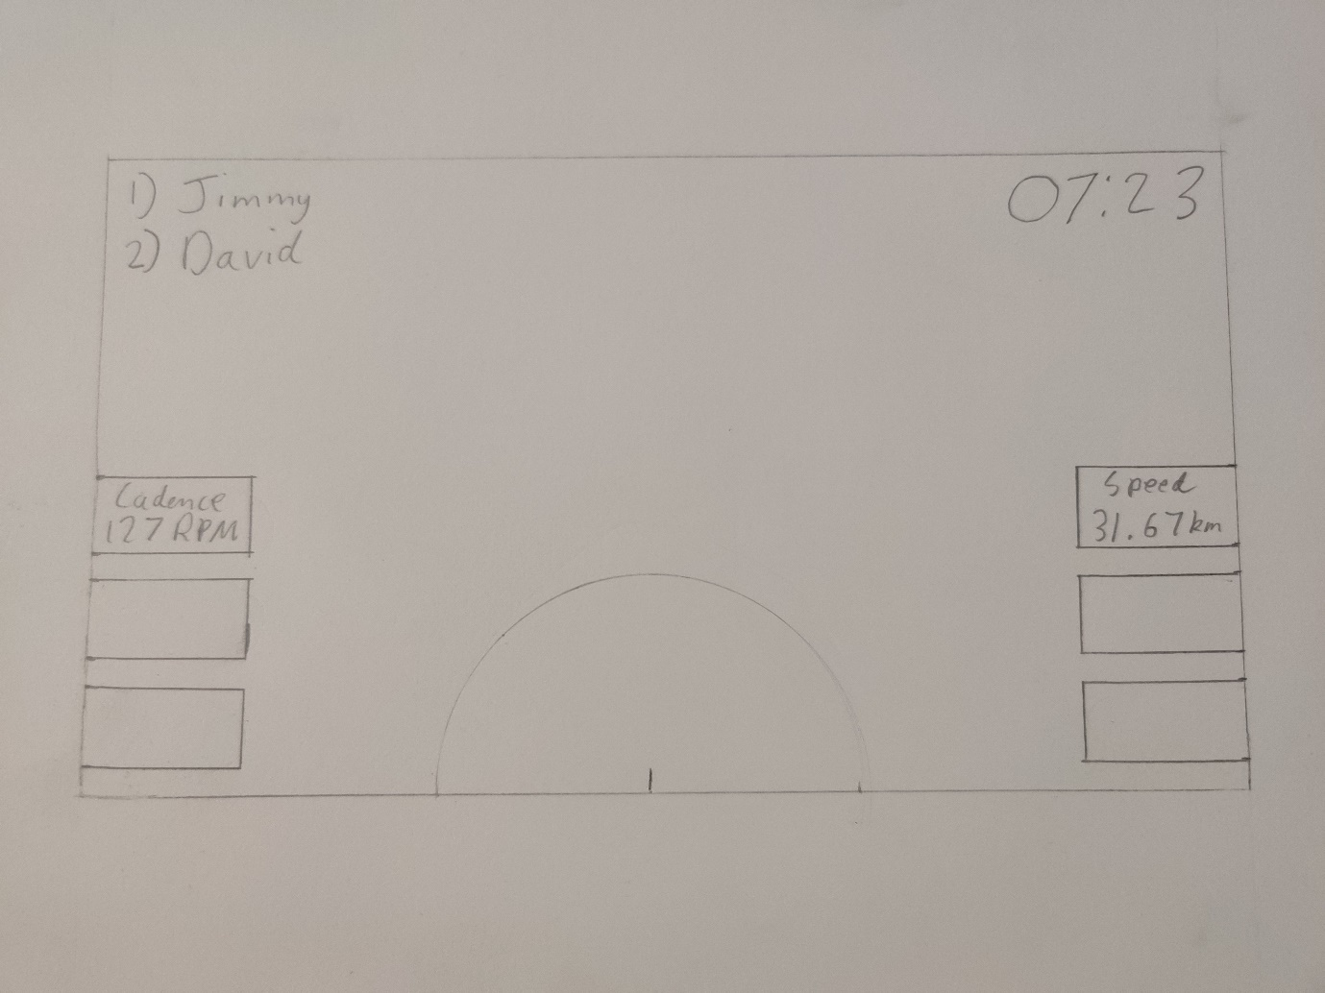
Figure 20 – Initial mock-up for the Heads-Up Display for the VR game for the Cycling Against Friends/Ghosts feature
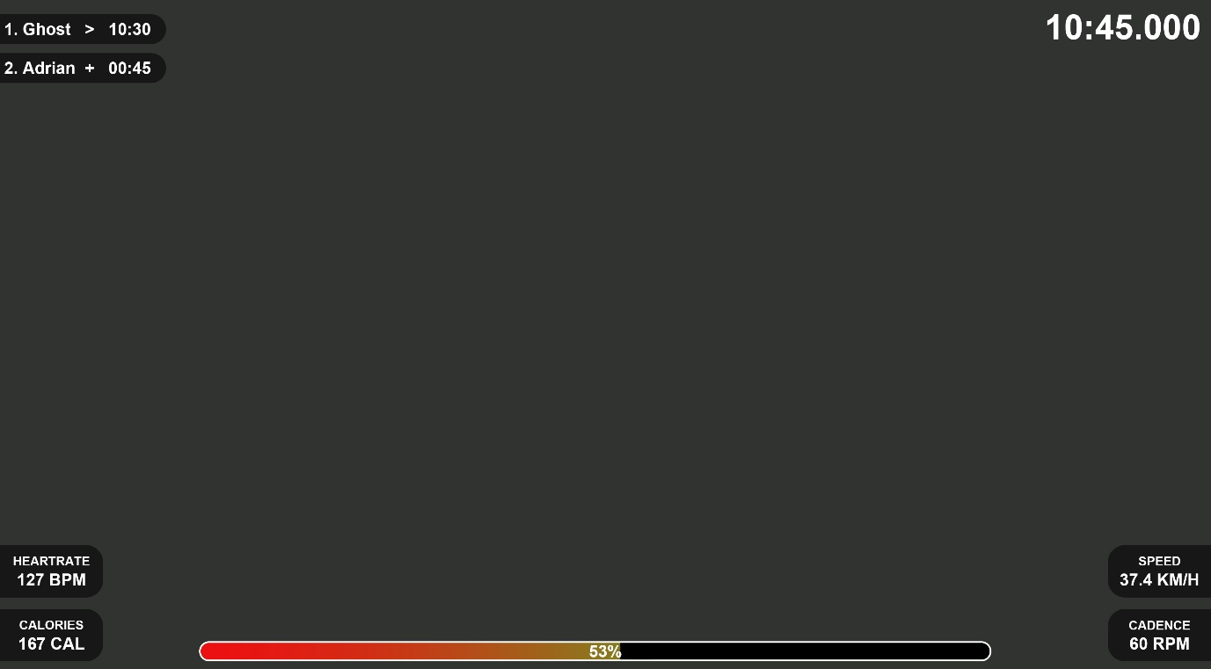
Figure 21 – Final Design for the HUD of the VR game with grey background developed in Photoshop
Figure 22 – Final Design for the HUD of the VR game developed in Photoshop
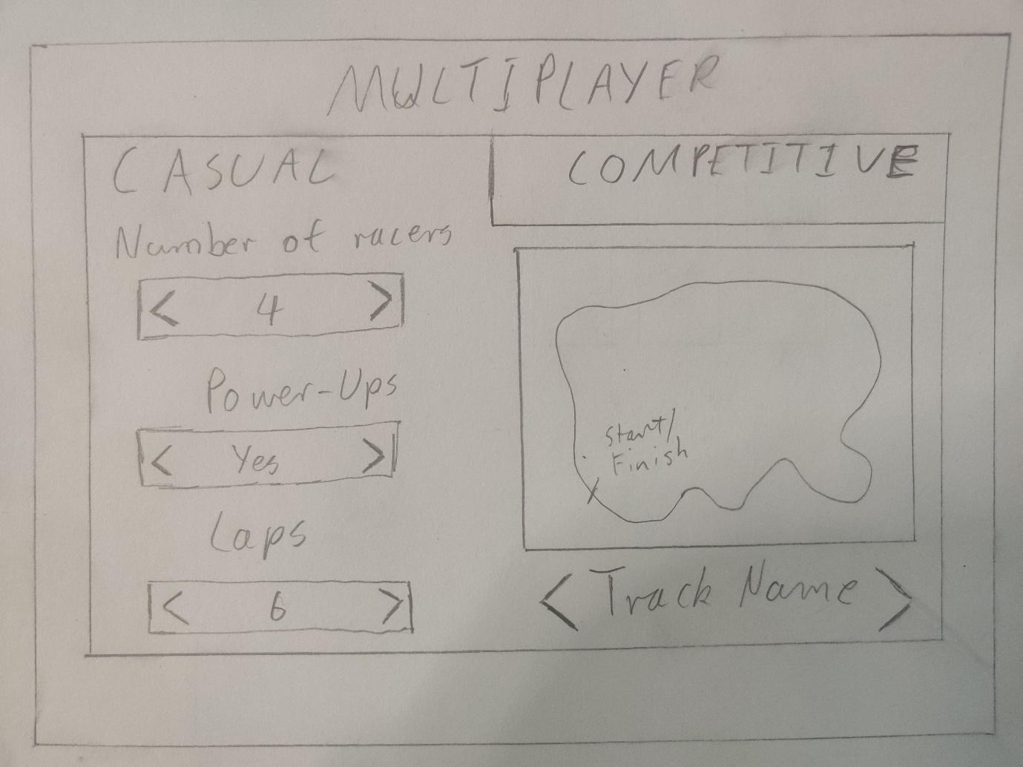
Figure 23 – Initial design for the options of the casual game mode of the multiplayer menu
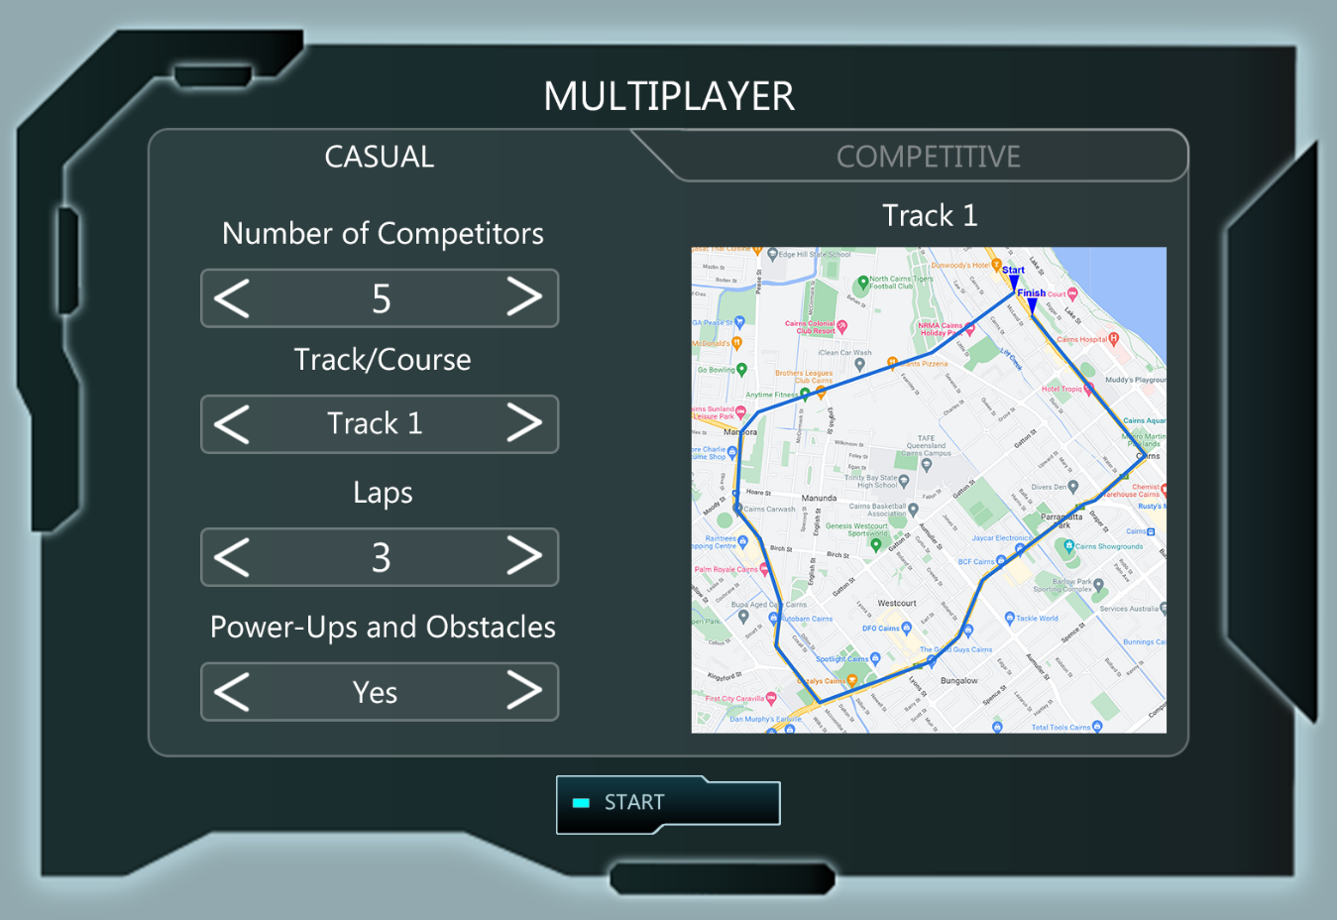
Figure 24 – Final design for the options of the casual game mode of the multiplayer menu
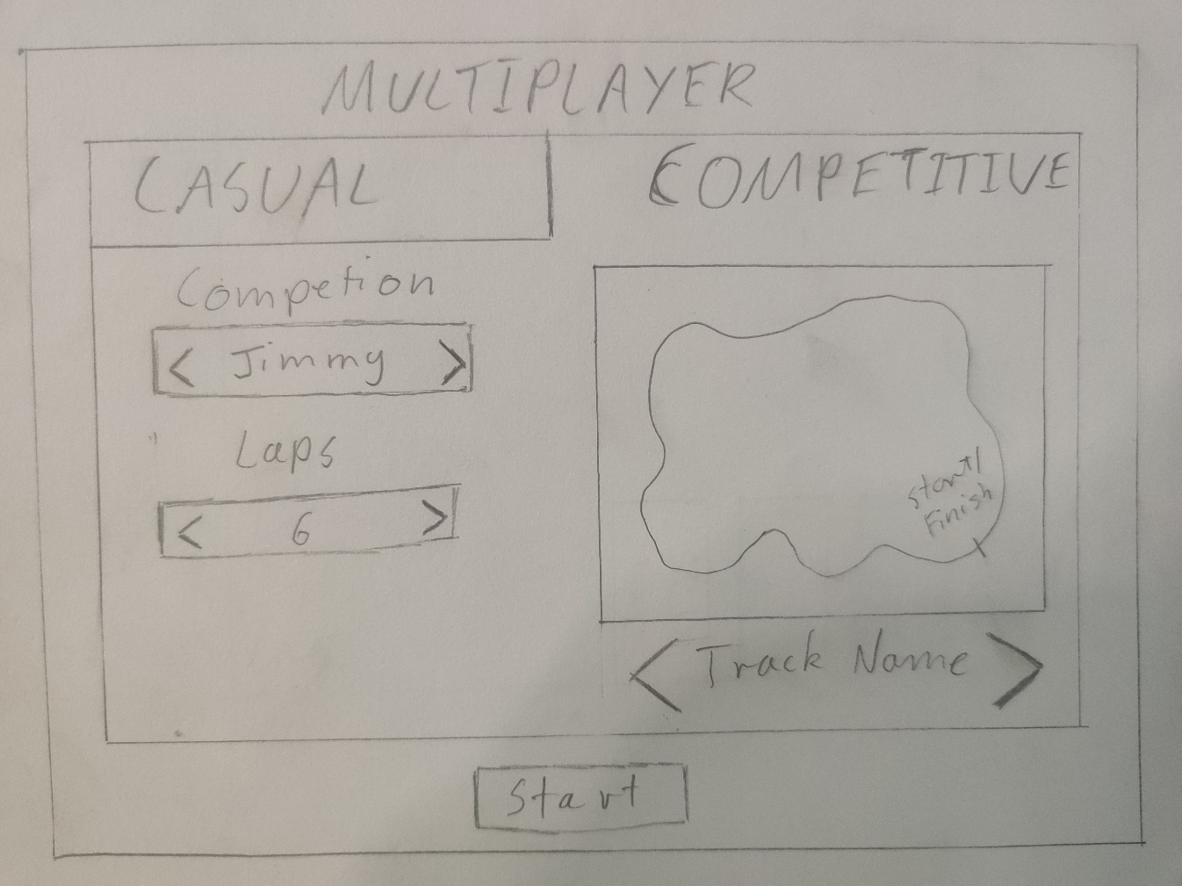
Figure 25 – Initial design for the options of the competitive game mode of the multiplayer menu
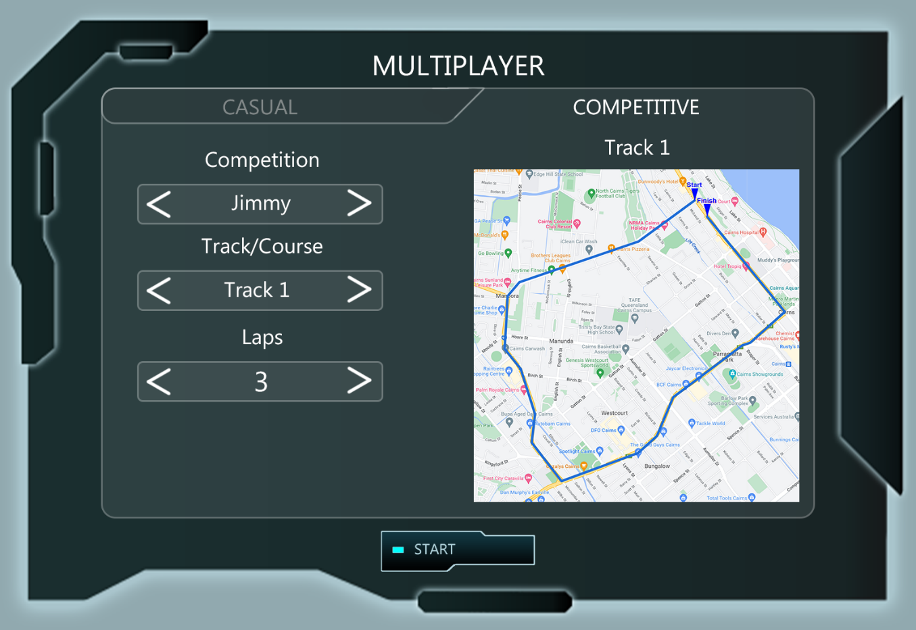
Figure 26 – Final design for the options of the competitive game mode of the multiplayer menu
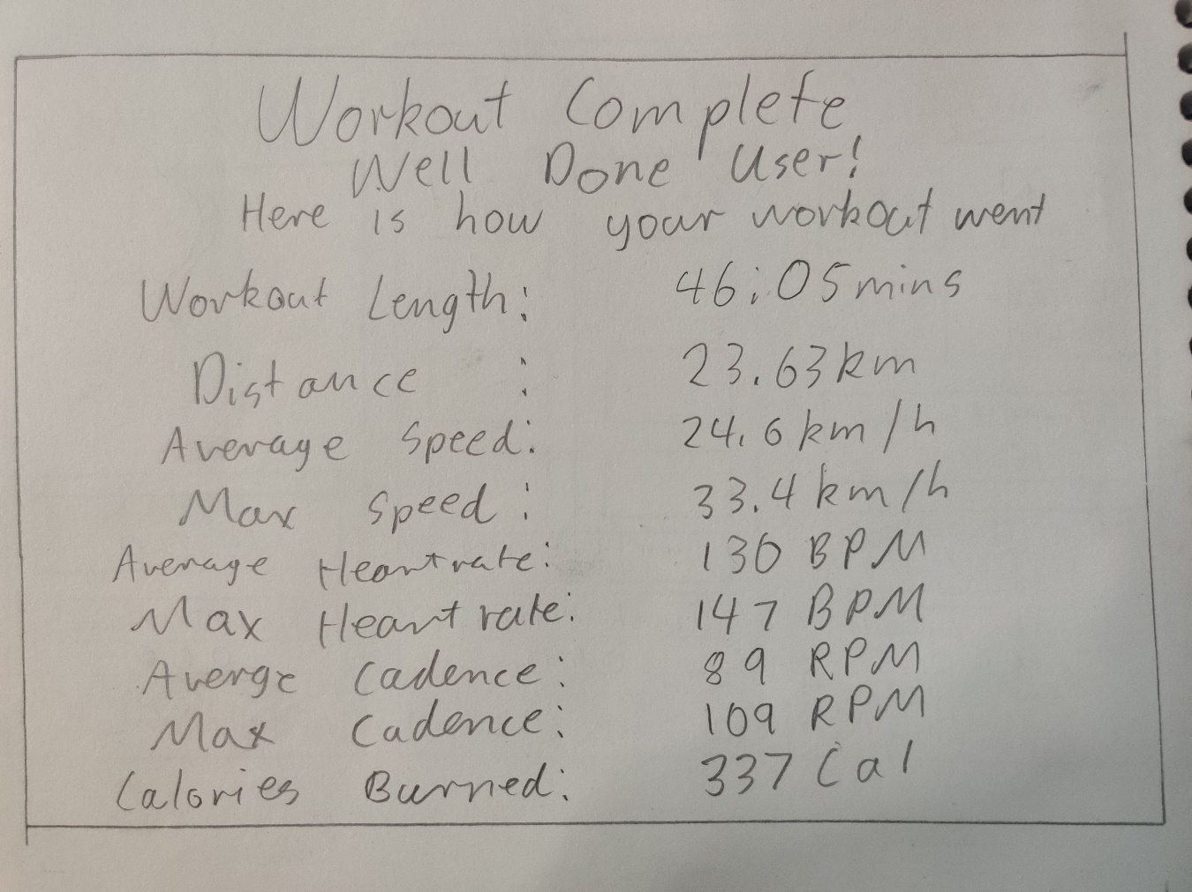
Figure 27 – Initial design of the first end of workout interface
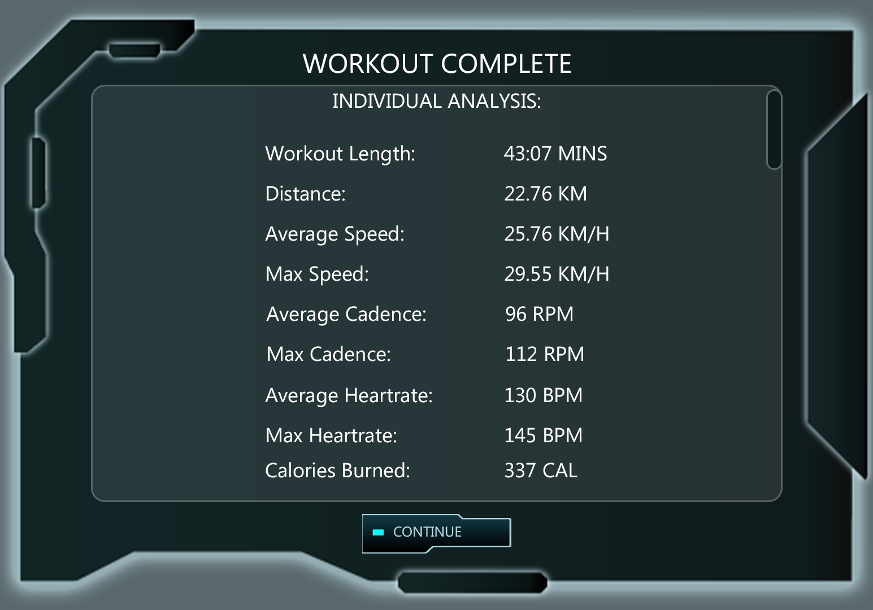
Figure 28 – Final design of the first end of workout interface
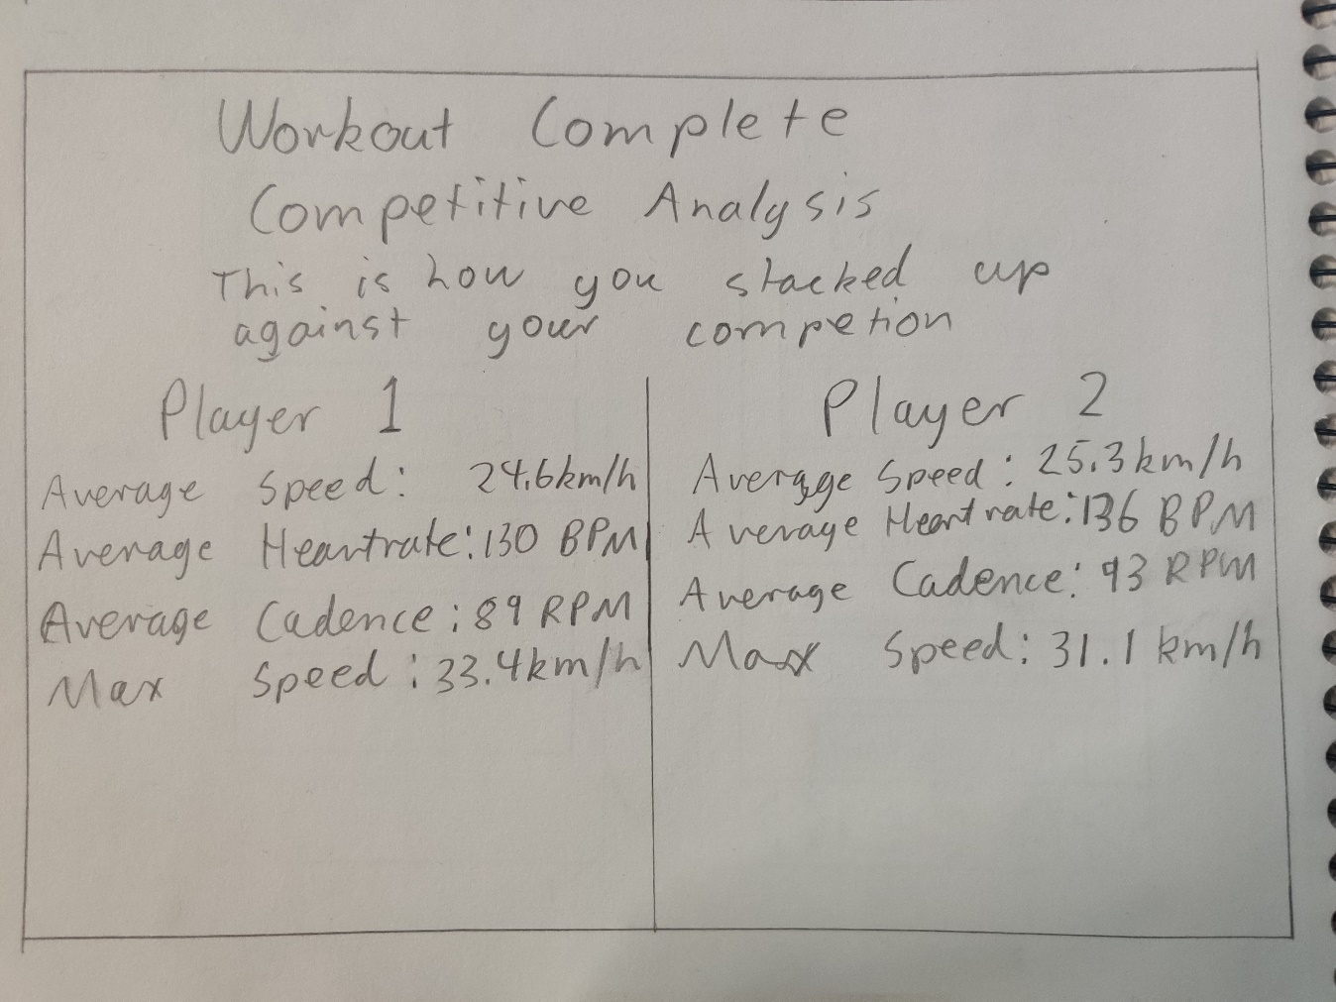
Figure 29 – Initial design of the second end of workout interface
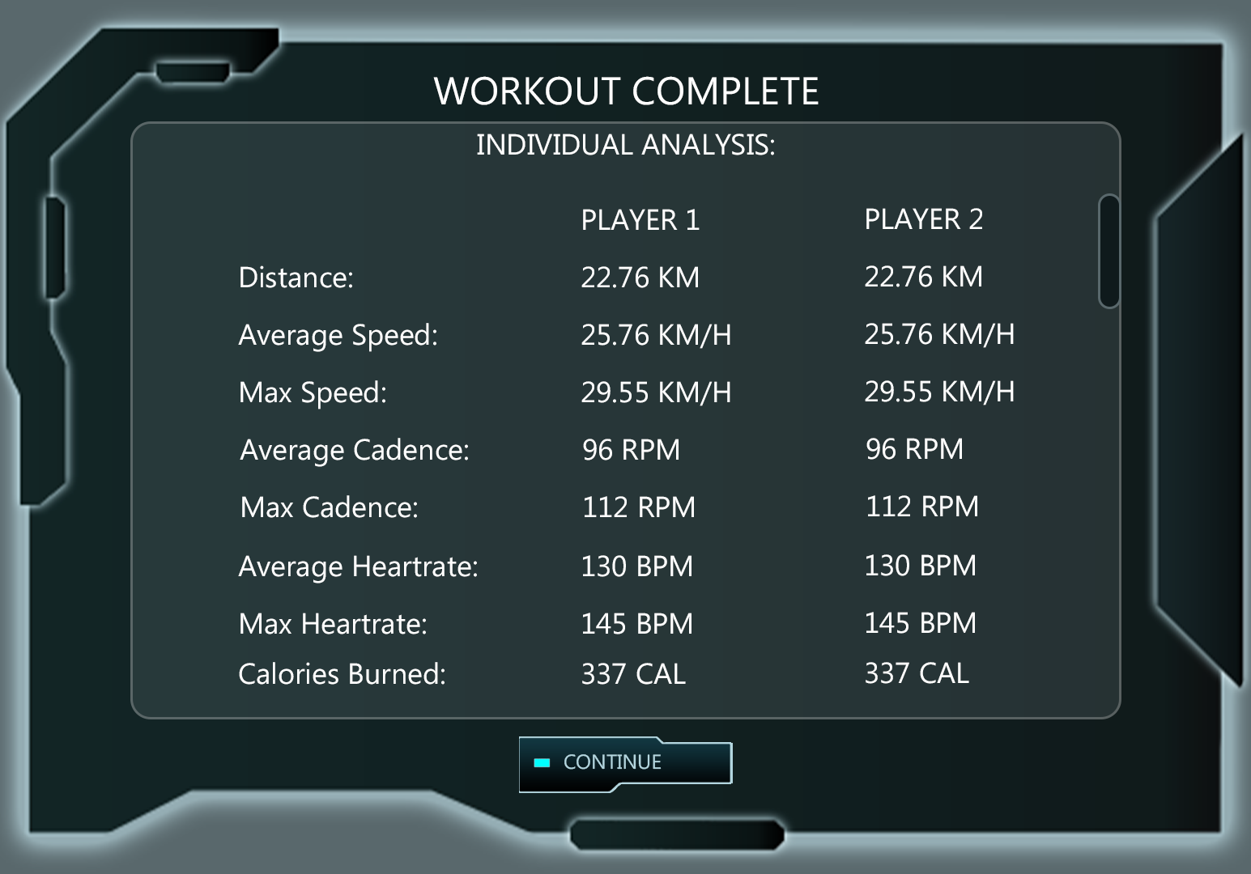
Figure 30 – Final design of the second end of workout interface
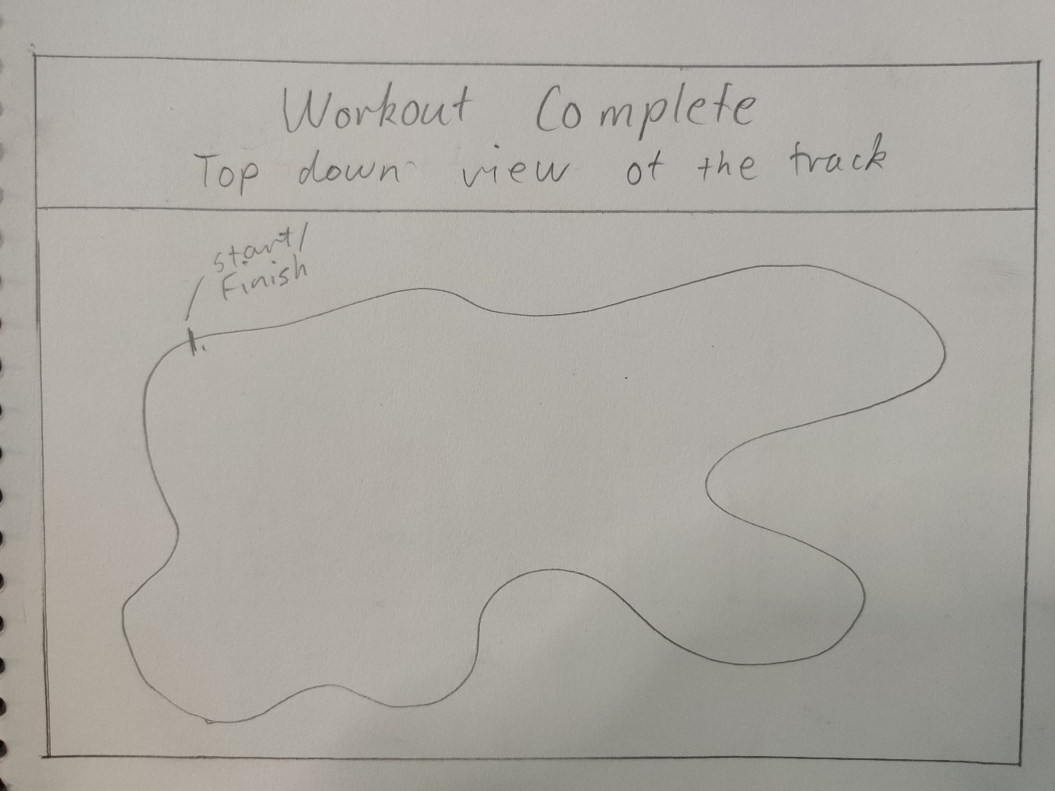
Figure 31 – Initial design of the third end of workout interface
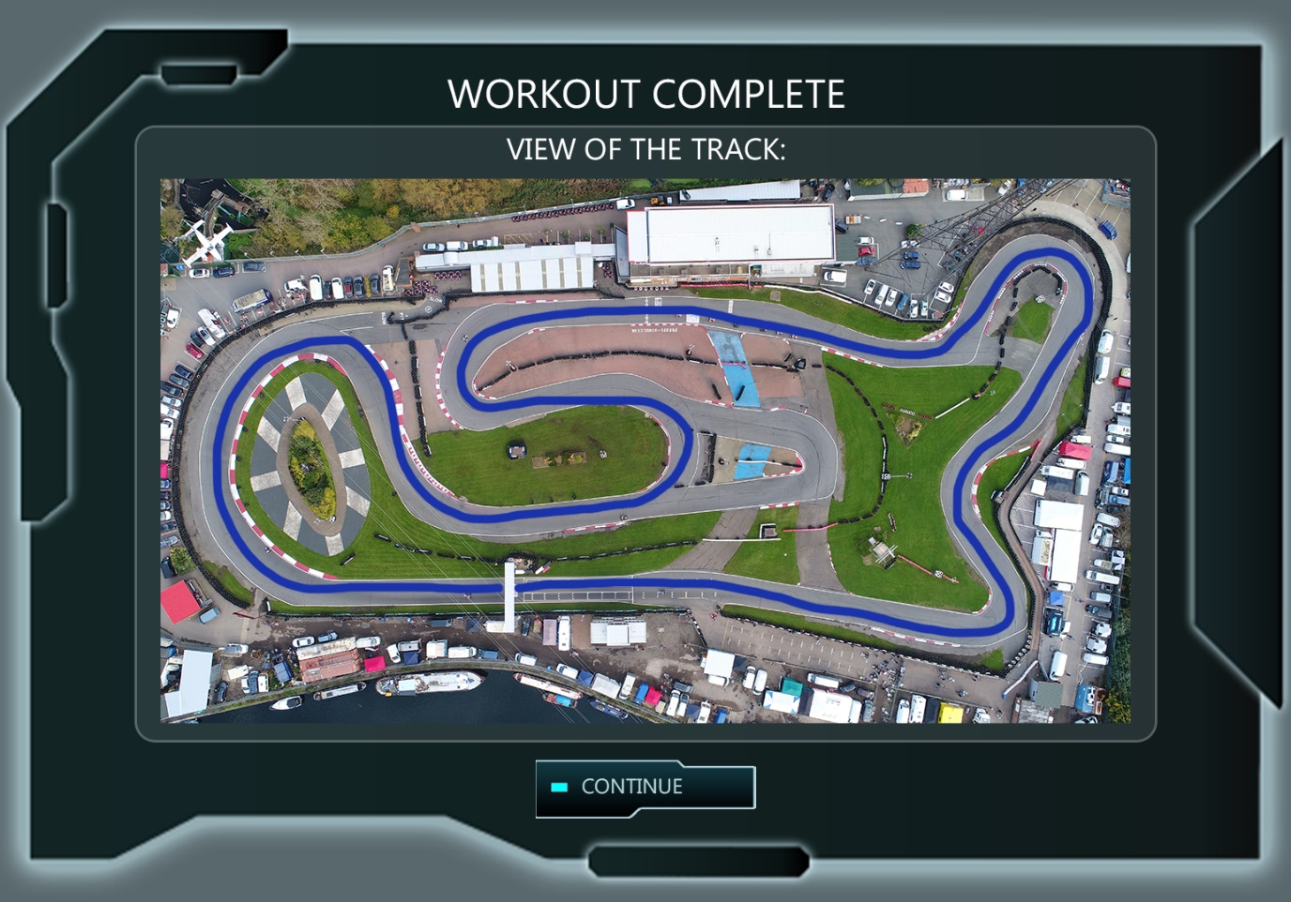
Figure 32 – Final design of the third end of workout interface

